7.2.27 Editors - 3D View - Header - Grease Pencil - Edit mode - Points menu
Edit Mode - Points Menu 1
Extrude Points 1
Smooth Points 1
Last Operator Smooth Stroke 1
Repeat 1
Factor 1
Selected points 2
Position 2
Thickness 2
Strength 2
UVs 2
Merge Points 2
Last Operator Merge Strokes 2
Mode 2
Draw on back 2
Additive drawing 2
Cyclic 2
Dissolve Points 2
Delete Strokes 2
Vertex Groups 3
Add New Group 3
Assing 3
Remove 3
Select 3
Deselect 3

Edit Mode - Points Menu

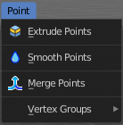
Extrude Points
Extrudes out the selected points. The new points stay connected with the original points of the stroke.

Smooth Points
Smoothens out the selected geometry.

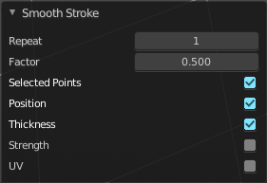
Last Operator Smooth Stroke

Repeat
How often to repeat the procedure.

Factor
The amount of the smoothness to apply.

Selected points
When enabled, limits the effect to only the selected points within the stroke.

Position
When enabled, the operator affect the points location.

Thickness
When enabled, the operator affect the points thickness.

Strength
When enabled, the operator affect the points strength (alpha).

UVs
When enabled, the operator affect the UV rotation on the points.

Merge Points
Allows you to paint a new stroke between the selected vertices. The selected points are not merged though, but a new stroke is created.

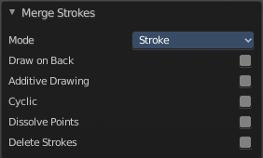
Last Operator Merge Strokes

Mode
Here you can choose between stroke or point mode.
This feature is not documented in the Blender manual, there is no explanation in the tool tip, and it is not to find out what the difference is. Both do the same.

Draw on back
Draw the new stroke below all other strokes.

Additive drawing
Add to previous drawing

Cyclic
Close the new stroke

Dissolve Points
Dissolve the old selected points.

Delete Strokes
Deletes the old selected strokes.

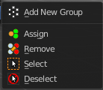
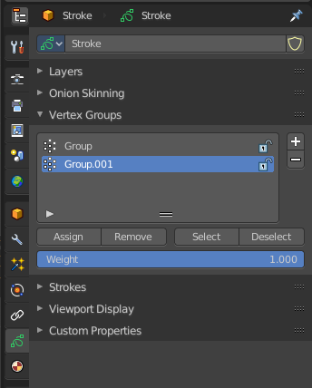
Vertex Groups
This menu contains just the Add New Group button as long as no vertex group exists.

Add New Group
Adds a new group.

Assing
Assing the current selected geometry to the current active group.

Remove
Removes the current selected geometry from the current active group.

Select
Select the geometry of the current active group.

Deselect
Deselect the geometry of the current active group.

